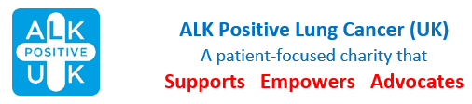
Booking Form
Radisson Red Hotel, Bath Road, Heathrow, UB7 0DU
Friday 27 September – Sunday 29 September

First Person:
email:
Telephone:
Address:
Second Person:
Second Person’s email:

I/we intend to be fully residential (please tick)
I/we would like to attend for one night (insert night)
I/we would like to be a day delegate (please tick)
If sharing a room, please indicate Double or Twin

It would be helpful if you could give an estimate of your travelling costs. £ ______________

Please tick the box if you wish to donate your traveling expenses.

If donating your expenses, are you able to complete a Gift Aid Declaration, which can be found on the Donating page of the website, and return to admin@alkpositive.org.uk?

Please return booking form as an attachment to an email to admin@alkpositive.org.uk or post to ALK Positive UK, Old Carw Farmhouse, Carrow Hill, St Brides Netherwent, Caldicot, Monmouthshire, NP26 3AU.

Please pay the booking fee of £10 per person by bank transfer to ALK Positive Lung Cancer UK (55-70-34 and 87815672) – please add your name and “conference” for reference, eg John Jones Conference or post cheque to address as above.

Lois Wright
Administrative Assistant
admin@alkpositive.org.uk

